#include <stdio.h>
#include <stdlib.h>
#include <string.h>
#include <float.h>

#define MAX_SLOTS 48
#define MAX_APPLIANCES 128
#define NAME_LEN 32

typedef struct {
char name[NAME_LEN];
double power_kw;
int duration;
int earliest_start;
int latest_end;
int priority;
int flexible;
int scheduled;
int start_slot;
} Appliance;

typedef struct {
Appliance apps[MAX_APPLIANCES];
int n_apps;
int n_slots;
double slot_price[MAX_SLOTS];
double slot_load[MAX_SLOTS];
double max_load_per_slot;
} Scheduler;

void init_scheduler(Scheduler *s, int n_slots, double max_load) {
s->n_apps = 0;
s->n_slots = n_slots;
s->max_load_per_slot = max_load;
for (int i = 0; i < n_slots; ++i) {
s->slot_price[i] = 0.20;
s->slot_load[i] = 0.0;
}
}

int add_appliance(Scheduler *s, const char *name, double power, int duration,
int earliest, int latest, int priority, int flexible) {
if (s->n_apps >= MAX_APPLIANCES) return -1;
Appliance *a = &s->apps[s->n_apps++];
strncpy(a->name, name, NAME_LEN-1);
a->name[NAME_LEN-1] = '\0';
a->power_kw = power;
a->duration = duration;
a->earliest_start = earliest;
a->latest_end = latest;
a->priority = priority;
a->flexible = flexible;
a->scheduled = 0;
a->start_slot = -1;
return 0;
}

int compare_priority(const void *p1, const void *p2) {
const Appliance *a = (const Appliance *)p1;
const Appliance *b = (const Appliance *)p2;
if (a->priority != b->priority) return a->priority - b->priority;
if (a->flexible != b->flexible) return b->flexible - a->flexible;
return 0;
}

int fits_at(Scheduler *s, Appliance *a, int st) {
if (st < 0) return 0;
if (st + a->duration > s->n_slots) return 0;
if (st < a->earliest_start) return 0;
if (st + a->duration > a->latest_end) return 0;
for (int j = 0; j < a->duration; ++j)
if (s->slot_load[st + j] + a->power_kw > s->max_load_per_slot)
return 0;
return 1;
}

double cost_if_at(Scheduler *s, Appliance *a, int st) {
double cost = 0.0;
for (int j = 0; j < a->duration; ++j)
cost += a->power_kw * s->slot_price[st + j];
return cost;
}

int schedule_fixed(Scheduler *s, Appliance *a) {
int limit = a->latest_end - a->duration;
for (int st = a->earliest_start; st <= limit; st++) {
if (fits_at(s, a, st)) {
for (int j = 0; j < a->duration; j++)
s->slot_load[st + j] += a->power_kw;
a->scheduled = 1;
a->start_slot = st;
return 1;
}
}
return 0;
}

int schedule_flexible(Scheduler *s, Appliance *a) {
double best_cost = DBL_MAX;
int best_start = -1;
int limit = a->latest_end - a->duration;

for (int st = a->earliest_start; st <= limit; st++) {
if (!fits_at(s, a, st)) continue;
double c = cost_if_at(s, a, st);
if (c < best_cost) {
best_cost = c;
best_start = st;
}
}

if (best_start >= 0) {
for (int j = 0; j < a->duration; j++)
s->slot_load[best_start + j] += a->power_kw;
a->scheduled = 1;
a->start_slot = best_start;
return 1;
}
return 0;
}

void run_scheduler(Scheduler *s) {
qsort(s->apps, s->n_apps, sizeof(Appliance), compare_priority);

for (int i = 0; i < s->n_apps; i++)
if (!s->apps[i].flexible)
schedule_fixed(s, &s->apps[i]);

for (int i = 0; i < s->n_apps; i++)
if (s->apps[i].flexible)
schedule_flexible(s, &s->apps[i]);
}

void print_report(Scheduler *s) {
printf("\n--- Scheduler Report ---\n");
printf("Slots: %d, Max Load: %.2f kW\n\n", s->n_slots, s->max_load_per_slot);

printf("Slot | Price | Load\n");
printf("---------------------\n");

double total_energy = 0.0;
double total_cost = 0.0;
double peak_load = 0.0;

for (int i = 0; i < s->n_slots; i++) {
printf("%4d | %.3f | %.3f\n", i, s->slot_price[i], s->slot_load[i]);
total_energy += s->slot_load[i];
total_cost += s->slot_load[i] * s->slot_price[i];
if (s->slot_load[i] > peak_load) peak_load = s->slot_load[i];
}

printf("\nAppliance Schedule:\n");
for (int i = 0; i < s->n_apps; i++) {
Appliance *a = &s->apps[i];
printf("%-20s | %.2f kW | Start %d | Dur %d | %s\n",
a->name, a->power_kw, a->start_slot, a->duration,
a->scheduled ? "SCHEDULED" : "UNSCHEDULED");
}

printf("\nTotal Energy: %.3f kWh\n", total_energy);
printf("Total Cost: %.3f\n", total_cost);
printf("Peak Load: %.3f kW\n", peak_load);
}

void user_input(Scheduler *s) {
int n;
printf("\nEnter number of appliances: ");
scanf("%d", &n);

for (int i = 0; i < n; i++) {
char name[NAME_LEN];
double power;
int dur, es, le, pr, flex;

printf("\nAppliance %d name: ", i+1);
scanf(" %s", name);

printf("Power (kW): ");
scanf("%lf", &power);

printf("Duration (slots): ");
scanf("%d", &dur);

printf("Earliest start slot: ");
scanf("%d", &es);

printf("Latest end slot: ");
scanf("%d", &le);

printf("Priority (lower = higher priority): ");
scanf("%d", &pr);

printf("Flexible? 1=Yes 0=No: ");
scanf("%d", &flex);

add_appliance(s, name, power, dur, es, le, pr, flex);
}
}

int main() {
Scheduler s;
init_scheduler(&s, 24, 5.0);

double prices[24] = {
0.12,0.12,0.10,0.10,0.10,0.12,
0.15,0.20,0.25,0.30,0.30,0.28,
0.26,0.24,0.22,0.22,0.24,0.28,
0.30,0.35,0.33,0.28,0.20,0.15
};

for (int i = 0; i < 24; i++)
s.slot_price[i] = prices[i];

int choice;
printf("1. Use automatic sample appliances\n2. Enter appliances manually\nChoice: ");
scanf("%d", &choice);

if (choice == 1) {
add_appliance(&s, "Fridge", 0.15, 24, 0, 24, 1, 0);
add_appliance(&s, "Washer", 0.8, 2, 7, 20, 2, 1);
add_appliance(&s, "Dishwasher", 1.0, 1, 18, 24, 3, 1);
add_appliance(&s, "EVCharge", 3.3, 4, 22, 24, 1, 1);
add_appliance(&s, "AC", 1.2, 6, 20, 24, 1, 0);
} else {
user_input(&s);
}

run_scheduler(&s);
print_report(&s);

return 0;
}
OUTPUT:
Step1:
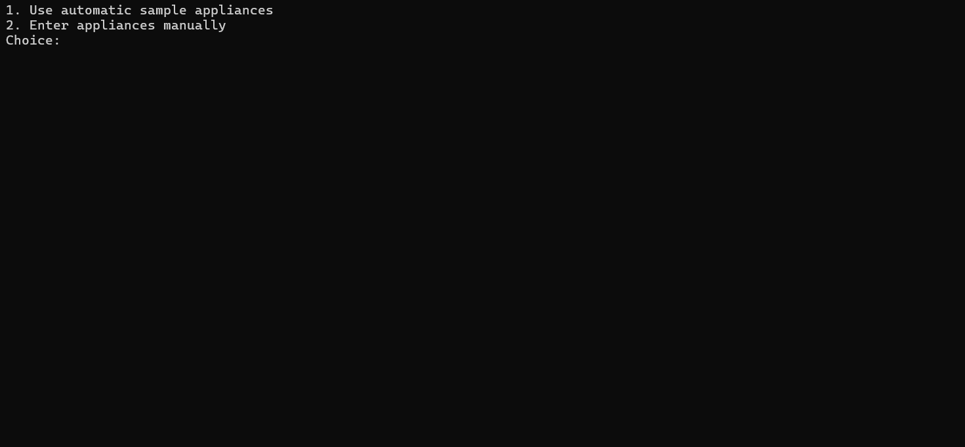
Step2:
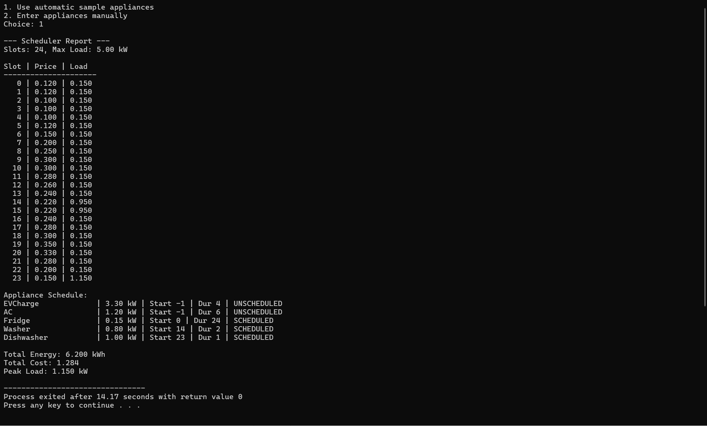
Or
